**UML DIAGRAMS**

1. **Use case diagram**

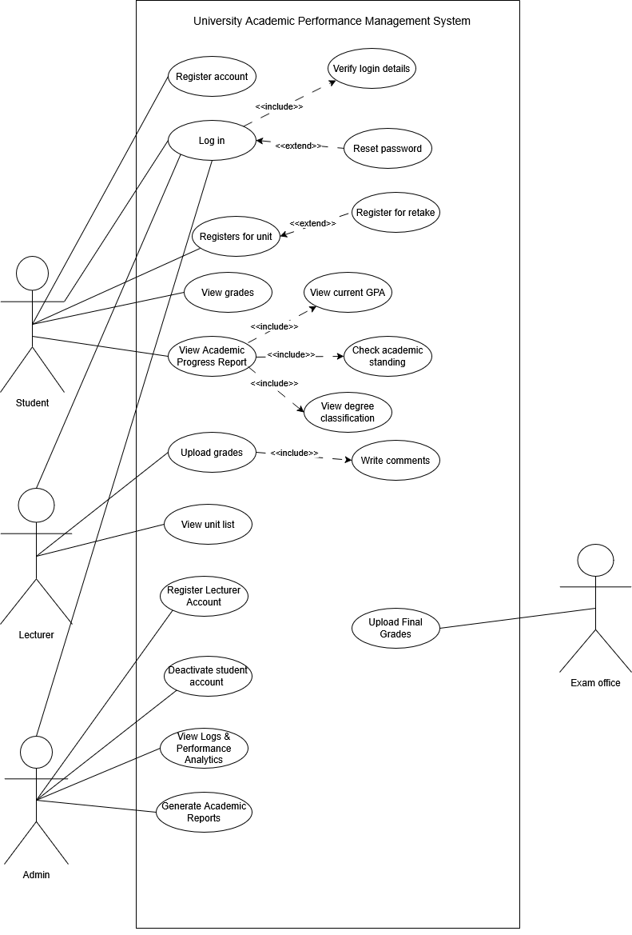

1. **Sequence diagram**

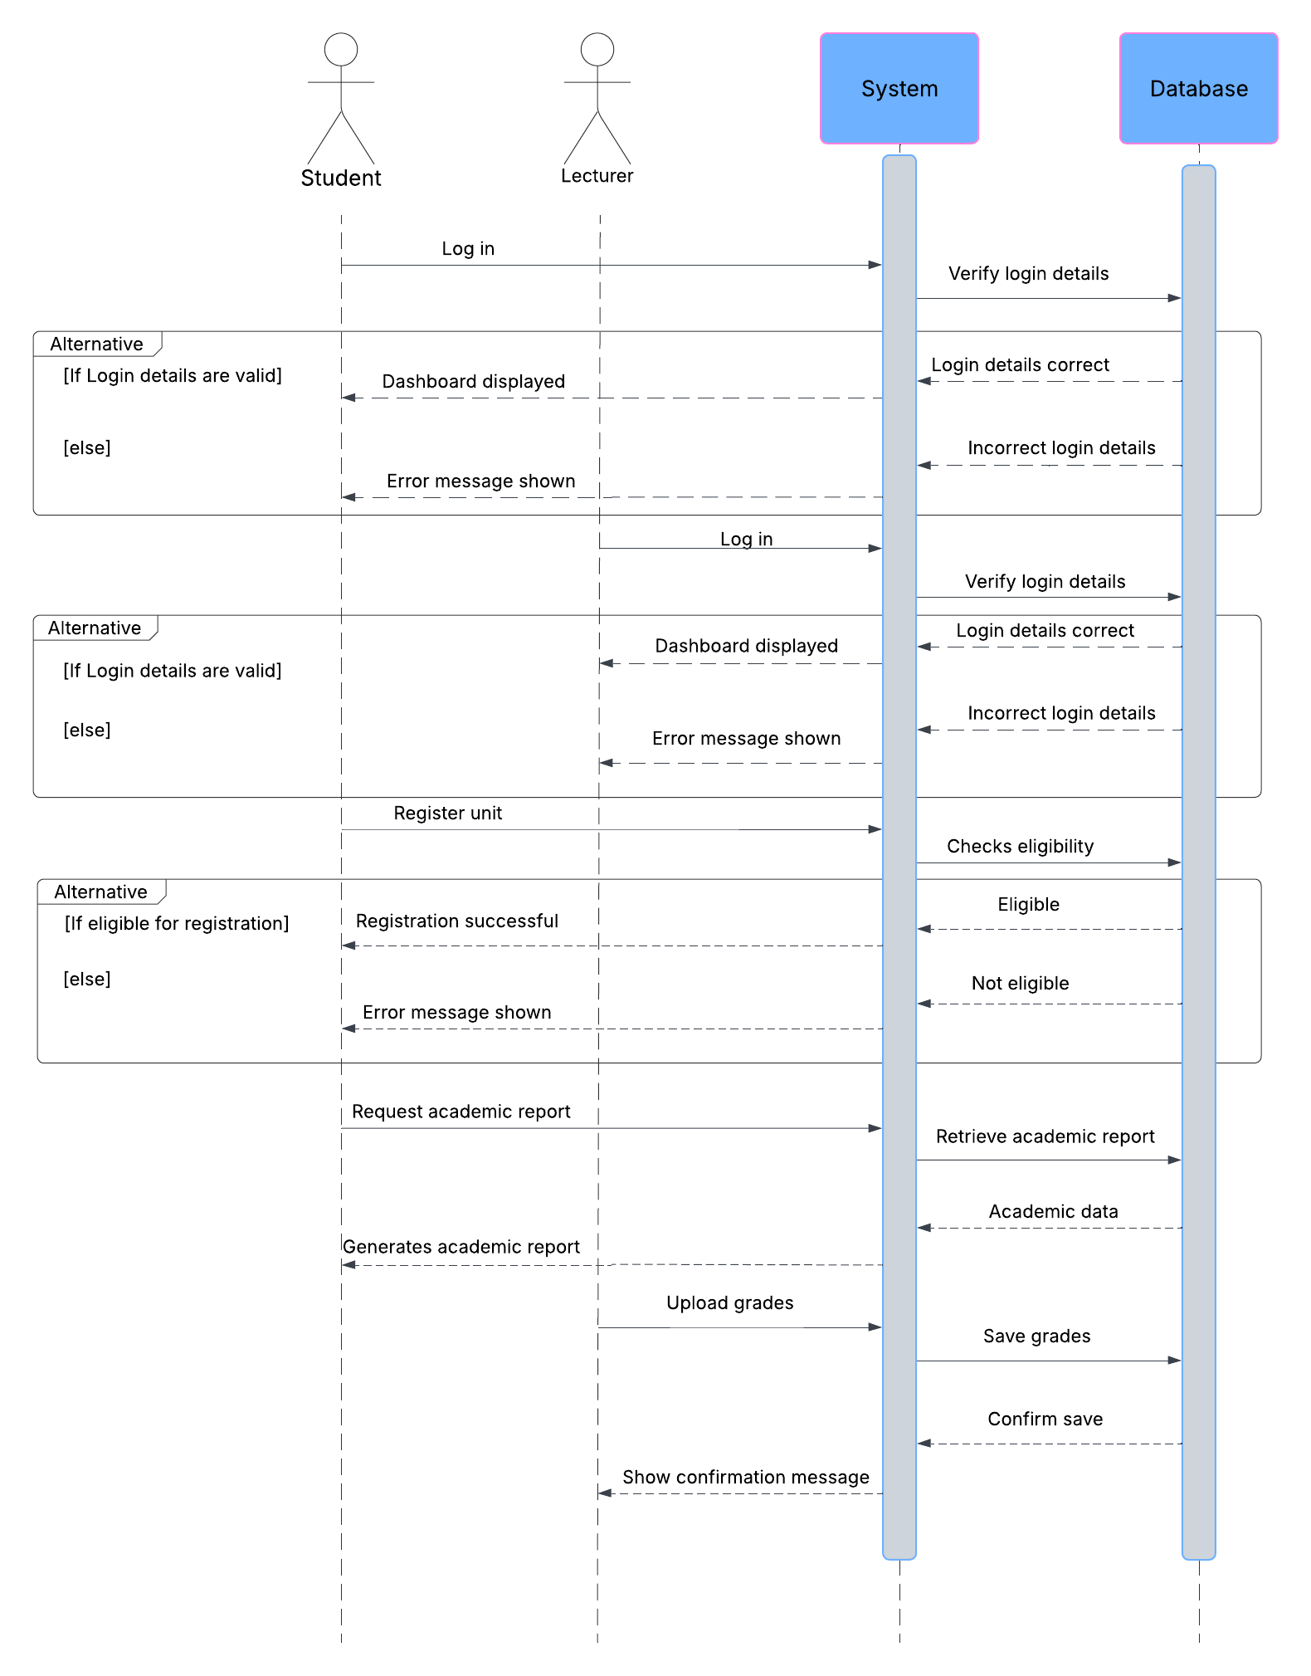

1. **ERD diagram**

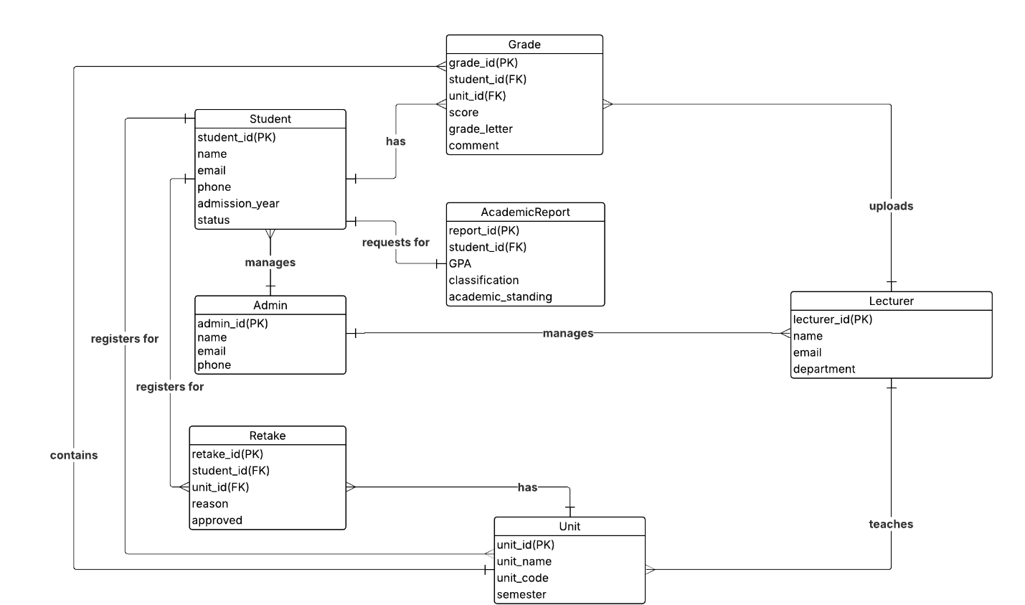

1. **Class diagram**

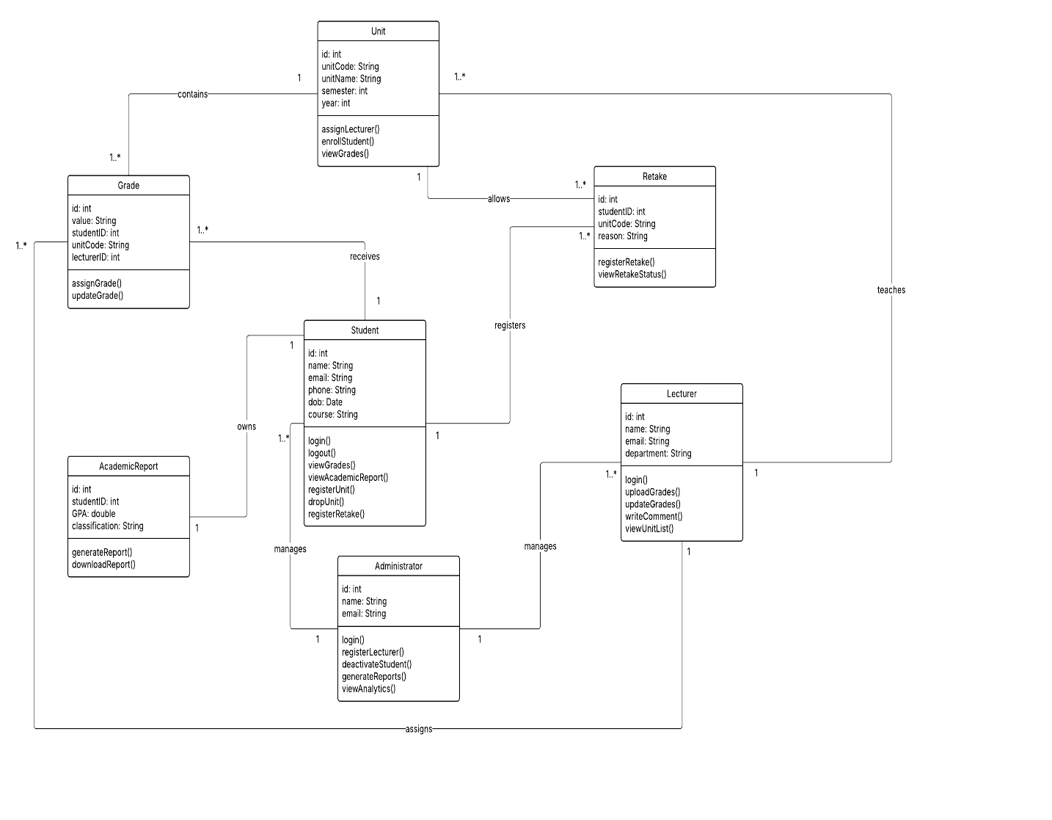

1. **Activity diagram**

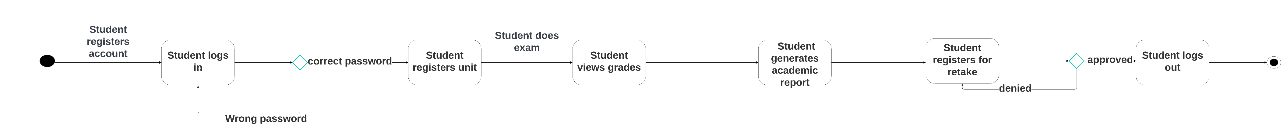

1. Activity diagram